Aplicación 1.2: Demanda de carne

library(readr)  
DEM_CARNE <- read_csv("DEM_CARNE.csv")

## Parsed with column specification:  
## cols(  
## P = col_double(),  
## Q = col_double(),  
## Y = col_double()  
## )

DEM_CARNE

## # A tibble: 30 x 3  
## P Q Y  
## <dbl> <dbl> <dbl>  
## 1 10.8 11.6 488.  
## 2 13.0 12.0 365.  
## 3 9.24 8.92 541.  
## 4 4.61 33.9 760.  
## 5 13.0 4.56 422.  
## 6 7.71 17.6 578.  
## 7 7.40 18.8 562.  
## 8 7.52 11.6 301.  
## 9 8.76 7.64 380.  
## 10 13.5 7.88 479.  
## # … with 20 more rows

attach(DEM_CARNE)  
#  
# Método R estándar  
#  
# Gráficas  
#  
plot(Q ~ P, xlab="P", ylab="Q")

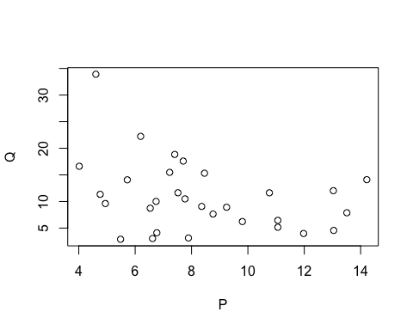

plot(Q ~ Y, xlab="Y", ylab="Q")

#

# Regresiones  
#  
lin_model <- lm(Q ~ P + Y)  
summary(lin_model)

##   
## Call:  
## lm(formula = Q ~ P + Y)  
##   
## Residuals:  
## Min 1Q Median 3Q Max   
## -6.4429 -2.6144 -0.5625 1.7284 6.8800   
##   
## Coefficients:  
## Estimate Std. Error t value Pr(>|t|)   
## (Intercept) 1.345236 3.301677 0.407 0.68690   
## P -0.767780 0.259243 -2.962 0.00631 **   
## Y 0.039020 0.005762 6.772 2.84e-07 ***  
## ---  
## Signif. codes: 0 '***' 0.001 '**' 0.01 '*' 0.05 '.' 0.1 ' ' 1  
##   
## Residual standard error: 3.966 on 27 degrees of freedom  
## Multiple R-squared: 0.6709, Adjusted R-squared: 0.6465   
## F-statistic: 27.52 on 2 and 27 DF, p-value: 3.052e-07

#  
log_model <- lm(log(Q) ~ log(P) + log(Y))  
summary(log_model)

##   
## Call:  
## lm(formula = log(Q) ~ log(P) + log(Y))  
##   
## Residuals:  
## Min 1Q Median 3Q Max   
## -0.75112 -0.24829 0.01212 0.14647 0.67313   
##   
## Coefficients:  
## Estimate Std. Error t value Pr(>|t|)   
## (Intercept) -5.1704 1.4151 -3.654 0.0011 **   
## log(P) -0.5663 0.2148 -2.636 0.0137 *   
## log(Y) 1.4337 0.2287 6.270 1.04e-06 ***  
## ---  
## Signif. codes: 0 '***' 0.001 '**' 0.01 '*' 0.05 '.' 0.1 ' ' 1  
##   
## Residual standard error: 0.3941 on 27 degrees of freedom  
## Multiple R-squared: 0.6234, Adjusted R-squared: 0.5955   
## F-statistic: 22.35 on 2 and 27 DF, p-value: 1.882e-06

#  
n_lin_mod <- nls(Q ~ c1 + c2*P + c3*Y, start = list(c1=1, c2=-0.5, c3=0.1))  
summary(n_lin_mod)

##   
## Formula: Q ~ c1 + c2 * P + c3 * Y  
##   
## Parameters:  
## Estimate Std. Error t value Pr(>|t|)   
## c1 1.345236 3.301676 0.407 0.68690   
## c2 -0.767780 0.259243 -2.962 0.00631 **   
## c3 0.039020 0.005762 6.772 2.84e-07 ***  
## ---  
## Signif. codes: 0 '***' 0.001 '**' 0.01 '*' 0.05 '.' 0.1 ' ' 1  
##   
## Residual standard error: 3.966 on 27 degrees of freedom  
##   
## Number of iterations to convergence: 1   
## Achieved convergence tolerance: 3.128e-08

#  
nonlin_mod <- nls(Q ~ c1 + c2*P + c3*(Y^c4), start = list(c1=5, c2=-0.5, c3=0.001, c4=3))  
summary(nonlin_mod)

##   
## Formula: Q ~ c1 + c2 * P + c3 * (Y^c4)  
##   
## Parameters:  
## Estimate Std. Error t value Pr(>|t|)   
## c1 9.610e+00 2.677e+00 3.589 0.00135 **  
## c2 -5.059e-01 2.744e-01 -1.844 0.07663 .   
## c3 1.551e-07 9.184e-07 0.169 0.86722   
## c4 2.852e+00 8.962e-01 3.183 0.00376 **  
## ---  
## Signif. codes: 0 '***' 0.001 '**' 0.01 '*' 0.05 '.' 0.1 ' ' 1  
##   
## Residual standard error: 3.828 on 26 degrees of freedom  
##   
## Number of iterations to convergence: 10   
## Achieved convergence tolerance: 4.323e-06

#  
# Método R moderno: tidyverse  
#  
# Estadísticos descriptivos  
#  
library(skimr)  
skim(DEM_CARNE)

Data summary

|  |  |
| --- | --- |
| Name | DEM_CARNE |
| Number of rows | 30 |
| Number of columns | 3 |
| _______________________ |  |
| Column type frequency: |  |
| numeric | 3 |
| ________________________ |  |
| Group variables | None |

Variable type: numeric

|  |  |  |  |  |  |  |  |  |  |  |
| --- | --- | --- | --- | --- | --- | --- | --- | --- | --- | --- |
| skim_variable | n_missing | complete_rate | mean | sd | p0 | p25 | p50 | p75 | p100 | hist |
| P | 0 | 1 | 8.37 | 2.84 | 4.02 | 6.56 | 7.74 | 10.52 | 14.22 | ▅▇▃▃▃ |
| Q | 0 | 1 | 10.89 | 6.67 | 2.90 | 6.29 | 9.81 | 14.09 | 33.91 | ▇▅▃▁▁ |
| Y | 0 | 1 | 409.42 | 127.84 | 184.80 | 320.38 | 385.93 | 485.45 | 760.34 | ▂▇▃▂▁ |

#  
library(tidyverse)

## ── Attaching packages ─────────────────────────────────────────────────────────────────────────────────────────────────────── tidyverse 1.3.0 ──

## ✓ ggplot2 3.3.2 ✓ dplyr 1.0.2  
## ✓ tibble 3.0.3 ✓ stringr 1.4.0  
## ✓ tidyr 1.1.2 ✓ forcats 0.5.0  
## ✓ purrr 0.3.4

## ── Conflicts ────────────────────────────────────────────────────────────────────────────────────────────────────────── tidyverse_conflicts() ──  
## x dplyr::filter() masks stats::filter()  
## x dplyr::lag() masks stats::lag()

#  
# Gráficas  
#  
g1 <- ggplot(DEM_CARNE, aes(x=P, y=Q)) +  
 geom_point() + geom_smooth(method = "lm", se = FALSE) + labs(x = "P", y = "Q",   
 title = "Relación parcial Q - P")  
g1

## `geom_smooth()` using formula 'y ~ x'

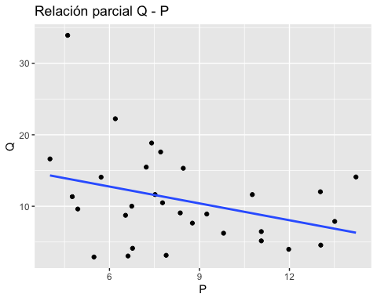

g2 <- ggplot(DEM_CARNE, aes(x=Y, y=Q)) +  
 geom_point() + geom_smooth(method = "lm", se = FALSE) + labs(x = "Y", y = "Q",   
 title = "Relación parcial Q - Y")  
g2

## `geom_smooth()` using formula 'y ~ x'

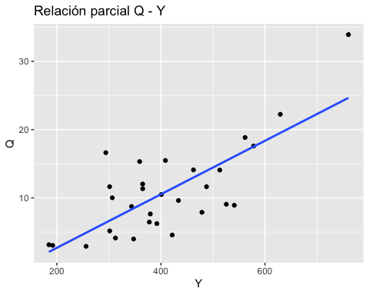

#  
library(moderndive)  
## Correlaciones  
#  
DEM_CARNE %>% get_correlation(Q ~ P)

## # A tibble: 1 x 1  
## cor  
## <dbl>  
## 1 -0.334

DEM_CARNE %>% get_correlation(Q ~ Y)

## # A tibble: 1 x 1  
## cor  
## <dbl>  
## 1 0.751

#  
# Regresión lineal:  
modelo_lineal <- lm(Q ~ P + Y, data = DEM_CARNE)  
# Tabla de resultados regression table:  
get_regression_table(modelo_lineal)

## # A tibble: 3 x 7  
## term estimate std_error statistic p_value lower_ci upper_ci  
## <chr> <dbl> <dbl> <dbl> <dbl> <dbl> <dbl>  
## 1 intercept 1.34 3.30 0.407 0.687 -5.43 8.12   
## 2 P -0.768 0.259 -2.96 0.006 -1.3 -0.236  
## 3 Y 0.039 0.006 6.77 0 0.027 0.051

get_regression_points(modelo_lineal)

## # A tibble: 30 x 6  
## ID Q P Y Q_hat residual  
## <int> <dbl> <dbl> <dbl> <dbl> <dbl>  
## 1 1 11.6 10.8 488. 12.1 -0.477  
## 2 2 12.0 13.0 365. 5.58 6.45   
## 3 3 8.92 9.24 541. 15.4 -6.44   
## 4 4 33.9 4.61 760. 27.5 6.43   
## 5 5 4.56 13.0 422. 7.79 -3.22   
## 6 6 17.6 7.71 578. 18.0 -0.396  
## 7 7 18.8 7.40 562. 17.6 1.26   
## 8 8 11.6 7.52 301. 7.34 4.30   
## 9 9 7.64 8.76 380. 9.43 -1.78   
## 10 10 7.88 13.5 479. 9.66 -1.78   
## # … with 20 more rows

#